SOFTWARE DESIGN DESCRIPTION (SDD)
<AI-Integrated Web-Based Chemical Lab Inventory Management System>


Submitted by:
Khazima Amin (1202)

Submitted to:
Mr. Faisal Shahzad

Department of Information Technology
Faculty of Computing
The Islamia University of Bahawalpur

Summary

The primary objective of this Software Design Description (SDD) is to provide a comprehensive architectural and technical blueprint for the AI-Integrated Web-Based Chemical Lab Inventory Management System (AI-CLIMS). Based on the formalized Software Requirement Specification (SRS), this system is designed to replace error-prone manual logbooks and static spreadsheets traditionally used in university laboratories.
The technical design relies on a modern, decoupled web architecture implementing the Model-View-Controller (MVC) pattern—realized through the Django framework. Python handles the back-end execution logic and drives the automated, predictive analytical algorithms to forecast stock depletion and generate low-stock alerts. On the data layer, a relational MySQL database ensures robust transaction tracking, safe role-based data storage, and historical logging for accountability.
Furthermore, this design incorporates a secure interface for QR-code data retrieval and localized Material Safety Data Sheet (MSDS) access via mobile view ports. This document outlines the physical database components, operational system diagrams, module layouts, and input constraints required to ensure full scalability, high availability, and compliance with academic laboratory standards.
Table of Contents
1. Application Architecture..........................................................................................4
1.1ArchitecturalOverview ..........................................................................................4
1.1.1 Models (Database Layer)..................................................................................4
1.1.2 Views (Business Logic Layer)............................................................................4
1.1.3 Templates (User Interface Layer).....................................................................4
1.2 List of Proposed Controllers (Django Views) & Functions ..............................4
1.2.1 AccountController (User Management)..........................................................4
1.2.2 InventoryController (Chemical Management)...............................................4
1.2.3 AI_PredictiveController (AI Logic)...................................................................5
1.2.4 QR_ServiceController (QR Scanner)...............................................................5
1.2.5 ReportGenerationController (Reports)............................................................5
1.3 External Libraries & APIs ...................................................................................6 1.4Coding Conventions ...............................................................................................6
2. Data Model Schema.................................................................................................6
2.1 Database Overview ..............................................................................................6
2.2Entity........................................................................................................................6
2.2.1 User Entity (Figure 3.1)......................................................................................6
2.2.2 Chemical Entity (Figure 3.2)..............................................................................7
2.2.3 Usage Log Entity (Figure 3.3)............................................................................7
2.3 Entity-Relationship Diagram (ERD) ..................................................................8
2.3.1 ERD with Crow's Foot Notation (Figure 3.4).................................................8
3. User Interface Design..............................................................................................9
3.1 Design Philosophy ................................................................................................9
3.1.1 Layout and White Space....................................................................................9
3.1.2 Navigation System..............................................................................................9
3.2 List of Core Pages & Control Details ..................................................................9
3.2.1 Login & Sign Up Screens....................................................................................9
3.2.2 Inventory Dashboard.........................................................................................9
3.2.3 Chemical Entry Form........................................................................................9
3.2.4 QR Scanner View................................................................................................9
3.3 Input Constraints & Validation Rules ................................................................9

1. Application Architecture
Architectural Overview
This system is designed using the “Model-View-Template (MVT)”architecture, which is Django’s way of implementing the standard Model-View-Controller (MVC) pattern. The application is divided into three main parts:
- Models: This layer connects directly with our MySQL database. It handles all the database tables, data rules, and storage logic.
- Views: This is the back-end controller layer written in Python. It contains the main business logic of the app, takes requests from the user, processes data using the models, and decides what to show next.
- Templates: This is the front-end user interface. It uses HTML5, CSS3, and Bootstrap to show the web-pages to the user in a clean and responsive design.
List of Proposed Controllers (Django Views) & Functions
According to our design, the system logic is handled by these main views and back-end functions:
1. AccountController (User Management)
- register_user(request): Takes user data like Name, Email, University ID, Password, and Role from the sign-up form. It validates the input and saves the account as "pending" until the Admin approves it.
- login_user(request): Checks the user's email and password against the MySQL database. If correct, it starts a session and sends the user to their correct dashboard (Admin, Lab In-charge, or Student).
- logout_user(request): Ends the user session and redirects them back to the login page.
2. InventoryController (Chemical Management)
- add_chemical(request): Allows the Admin or Lab In-charge to add new chemicals by entering the name, formula, quantity, shelf location, and expiry date.
- update_stock(request, chemical_id): Updates chemical details or lowers the chemical quantity when a student or staff member uses it in the lab.
- delete_chemical(request, chemical_id): Removes a chemical from the database if it is fully used up or expired.
3. AI_PredictiveController (AI Logic)
- analyze_usage_patterns(): Looks at the old usage log data saved in the system to see how chemicals are being used.
- generate_stock_alerts(): Uses Python logic to predict when a chemical might run out and shows a "Low Stock Alert" or "Expiry Alert" on the dashboard.
4. QR_ServiceController (QR Scanner)
- process_qr_scan(qr_payload): Takes the code string scanned from a chemical bottle, finds the matching ID in the MySQL database, and displays its safety details (MSDS) and stock status.
5. ReportGenerationController (Reports)
- generate_PDF_report(request, report_type): Gets data from the database (like a list of expired chemicals or monthly usage) and converts it into a downloadable PDF report.
External Libraries & APIs
We are using some basic open-source Python libraries to make these features work:
- qr-code: A Python package used to create unique QR code images for chemicals automatically when they are added to the system.
- Scikit-learn / Pandas: Basic Python tools used in our AI module to calculate usage trends and predict reorder dates.
- Report Lab: A standard library used to generate downloadable PDF files for lab reports.
Coding Conventions
Python Code: We will follow standard *PEP 8 guidelines* for writing Python code (like using snake_case for function names and Pascal Case for class names).
Front-end Styling: We will use standard Bootstrap framework classes to make sure our pages look neat and work properly on mobile screens.
2.Data Model Schema
Database Overview
The system uses a “MySQL” relational database to store all information. Each table (Entity) is designed to keep data organized and ensure that information like chemical quantities and user activities are tracked accurately.
Entity Descriptions
1. User Entity
This table stores information about everyone who uses the system.
- Attributes:User_ID (Primary Key), Full_Name, University_ID, Email, Password, Role (Admin, Lab In-charge, or Student), and Status.
- Purpose: To manage login access and control what each user can see or do in the system.
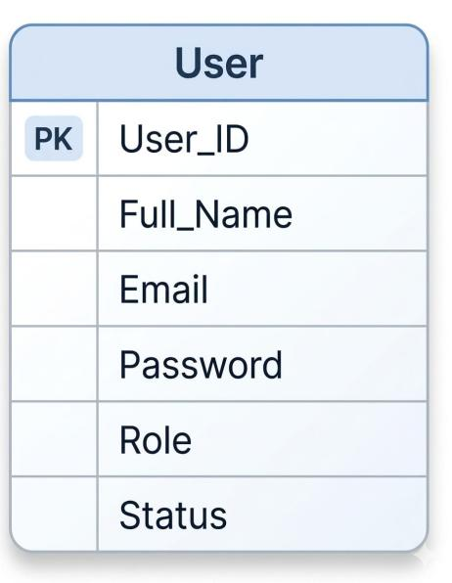
Figure:3.1
2. Chemical Entity
This is the main table that stores the details of every chemical in the lab.
- Attributes:Chemical_ID (Primary Key), Chemical_Name, Molecular_Formula, Quantity, Unit (e.g., ml, g), Expiry_Date, Location (Shelf/Rack number), and QR_Code_Data.
- Purpose: To keep a real-time record of what is available in the lab and monitor expiration dates.
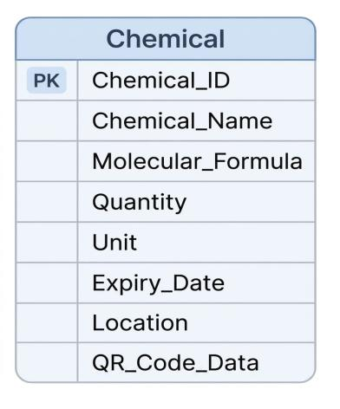
Figure3.2
3. Usage Log Entity
This table records every time a chemical is used or updated by any user in the lab.
Attributes:Log_ID (Primary Key), User_ID (Foreign Key), Chemical_ID (Foreign Key), Quantity_Used, and Timestamp (Date and Time).
Purpose: This data is saved for accountability and is used by the AI module to understand usage patterns.

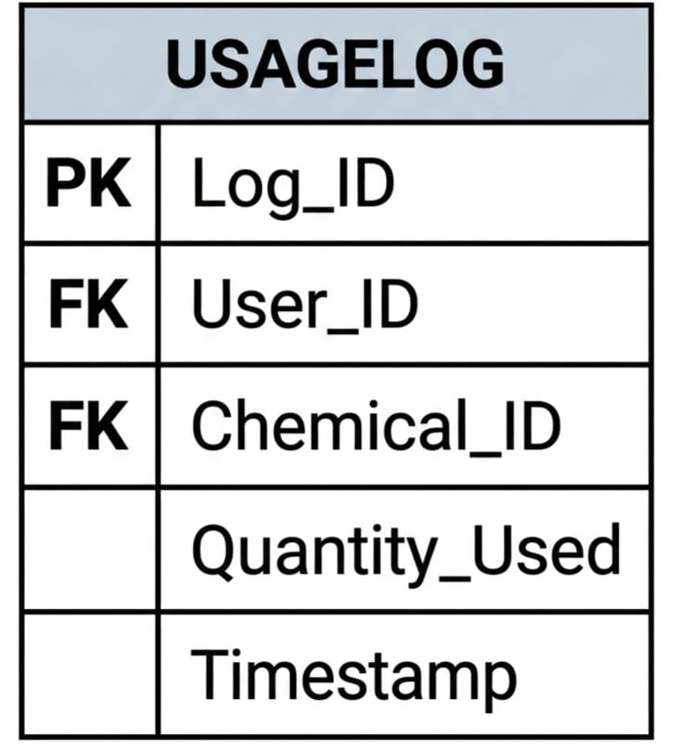 Figure:3.3

Entity-Relationship Diagram (ERD)
Here is the complete Entity-Relationship Diagram (ERD) that joins all three individual entities together using Crow's Foot notation, showing how users and chemicals interact through the logs.

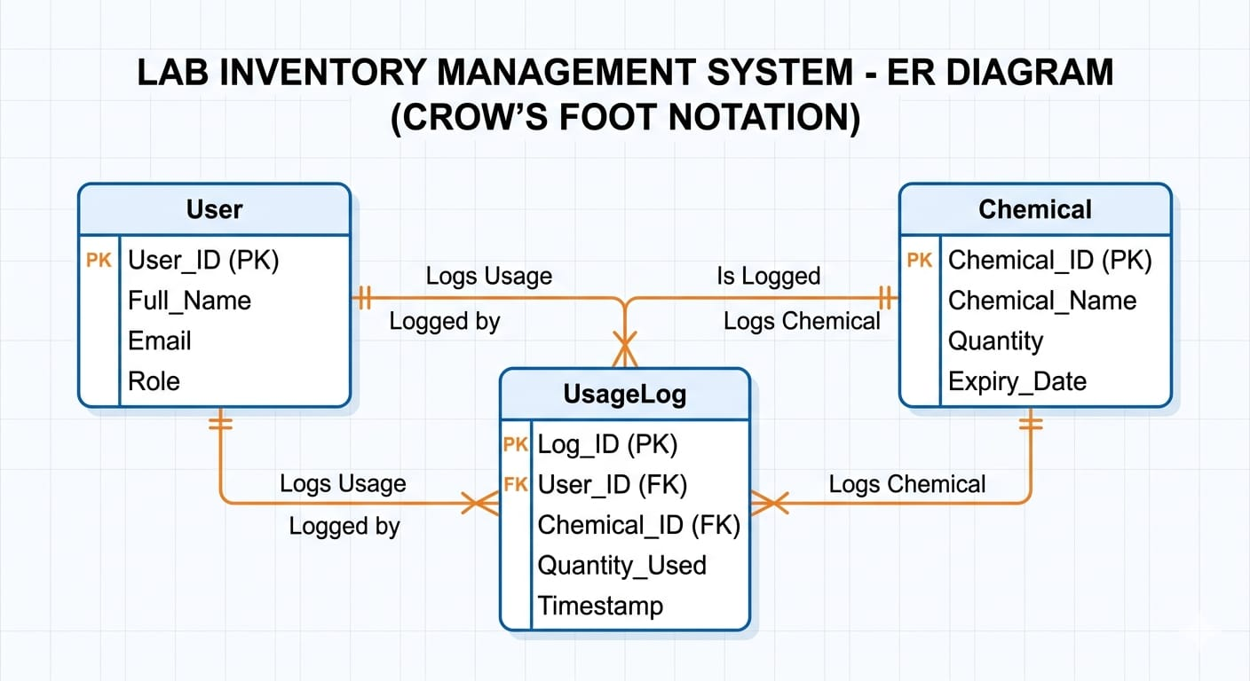
Figure3.4

4. User Interface
Design Philosophy
The user interface is designed to be user-friendly and simple so that lab staff and students can navigate the system without any confusion.
Layout: The application uses a clean and organized layout with plenty of white space to ensure that chemical names and data are clearly visible.
Navigation: A simple navigation bar is provided at the top or side to allow users to switch between the dashboard, inventory list, and reports quickly.
Responsiveness: The design is responsive, meaning it will automatically adjust its size to look good on both laptop screens and mobile phones (especially for QR scanning).
List of Core Pages & Control Details:
1. Login & Sign Up Screens
Description:These screens handle user access and account creation.

Controls:
- Input fields for Name, Email, and University ID.
- A drop down menu to select the user role (Student or Staff).
- Secure password fields.
- A "Submit" button to send data to the database.
2. Inventory Dashboard
Description: The main screen where users can see the overall status of the lab.
Controls:
- Summary cards showing "Total Chemicals" and "Low Stock Items."
- A notification area for expiry alerts.
- Quick action buttons to "Add New Item" or "Scan QR."
3. Chemical Entry Form
Description: Used to add or edit chemical details in the MySQL database.
Controls:
- Textboxes for Chemical Name and Molecular Formula.
- Number fields for Quantity (with validation to prevent negative numbers).
- A Date Picker to select the Expiry Date.
- A "Save" button that triggers the QR code generation.
4. QR Scanner View
Description: An interface that uses the device camera to identify chemicals.
Controls:
- A live camera window to scan the QR code.
- A "Close" button to exit the scanner.
- An automatic popup that displays the chemical's safety info (MSDS) once scanned.
5. Reports & AI Analytics
Description: Shows usage trends and stock predictions.
Controls:
- A table showing predicted reorder dates calculated by the AI module.
- A "Download PDF" button to save the inventory report for record-keeping.
Input Constraints (Validation Rules)
To keep the data accurate, we have added these simple rules:
- Empty Fields: The system will show a warning if any required field is left blank.
- Data Types: Quantity fields only accept numbers, and name fields only accept text.
- Dates: The system will not allow users to select an expiry date that has already passed.

